**Guided Capstone Project Report**

**By: Melissa Barona**

The pricing strategy of Big Mountain has been to charge a premium above the average price of resorts in its market segment. However, we would like to implement a more data-driven strategy that capitalizes on its facilities as much as possible, and that provides guidance on how to select a better value for its ticket price. To solve this problem, I used data containing information from 277 resorts in the US that can be considered part of the same market share as Big Mountain and built a linear model and a random forest model to predict the adult weekend price.

Both models suggest that the vertical drop, snow making area, total chairs, number of fast quads, number of runs, the distance of the longest run, the number of trams, and the skiable terrain area are the most relevant features in setting a competitive ticket price. This is consistent my initial exploration of the data. As shown in Figure 1, the adult weekend ticket price correlated positively with the vertical drop, the number of fast quads, the number of runs, the total number of chairs, and the snowmaking area, suggesting that visitors highly value the assets.

Currently, Big Mountain Resort charges $81.00 for the adult weekend ticket price. The model suggests that the resort should be charging $95.87, with a margin of $10.39, due to its large share in all of the features mentioned above compared to the large majority of the resorts in this dataset (Figure 2). The Model also suggests that the price benefits from not having any trams, and Big Mountain has none.

After the speaking with some of the stakeholders, we have learned that the resort is considering a number of scenarios to either cut costs or increase revenue from ticket prices. To cut expenses, the resort could close up to 1 run, and the ticket price would stay the same and make no difference on the revenue. Closing 3 to 10 runs could decrease revenue by $ 0.5-3.5 M (Figure 3).

Adding a run, increasing the vertical drop by 150 ft, and installing an additional chair lift would allow the resort to increase its price by $1.99 and increase revenue by ~ $3.5 M, which is greater than the cost of $ 1.5 M for a chair lift. After doing this, adding 2-4 acres of snow making or increasing the longest run by 0.2 miles makes no difference on the ticket price. Therefore, I suggest the resort to add a run, increase the vertical drop by 150 ft, and install a new chair lift. Overall this would have ~ $2 M in profit. If the business leaders would like to try other case scenarios using this model, I can provide the files and the python notebook with instructions so they could easily use the model as long as they have python installed on their computers.

Additional data such as the number of visitors for all of the resorts and the operating costs for some of the facilities like the snow making equipment, the cost of adding a fast quad, more runs, and run distance can help strengthen the model and better understand the importance of some features. For example, our model suggests that Big Mountain Resort is underpricing its visitors given its larger share of facilities compared to other resorts. The fact that our resort seems to be charging that much less that what's predicted suggests our resort might be undercharging. This also leads us to ask ourselves whether the rest of the resorts are mispricing as well. Would this be to try to drive up demand to cover additional costs? In this case, operating costs and number of visitors throughout the year will be useful additions to the model.

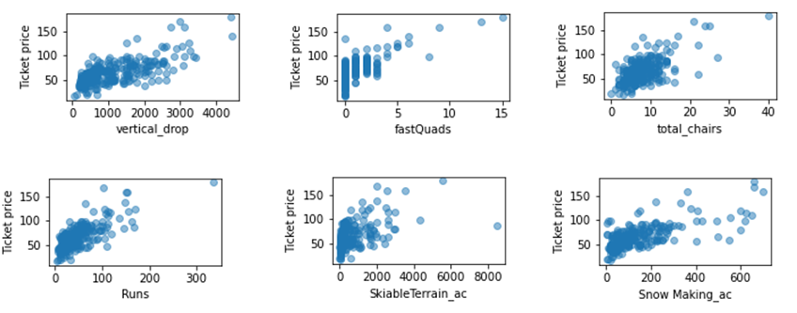

**Figure 1:** Correlation of ticket price with vertical drop, number of fast quads, total number of chairs, number of runs, skiable terrain area, and snow making area for all resorts on the dataset.

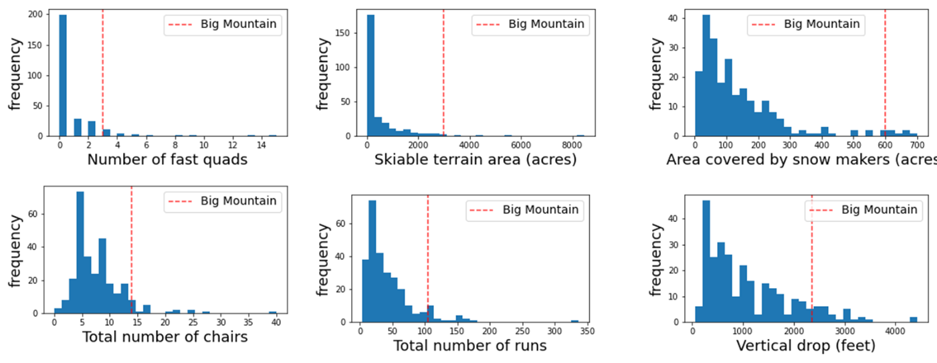

**Figure 2:** Distribution of assets for resorts in market share, and comparison of Big Mountain Resort’s share with the rest of the resorts.

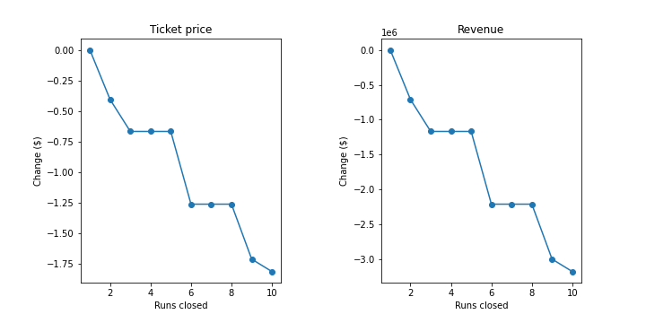

**Figure 3:** Effect of closing runs on revenue, assuming 3.5 M visitors a year, and 5 ticket purchases for each.